FORNAX™ ePlanCheck Rule
Rule Information
Rule ID | SSW 3.1.3.2 (a)
Rule Name | Main Drain-line - 150mm
Chapter | 3. Sanitary Works
Section | 3.1 Sanitary Drainage System
Handbook | Code of Practice on Sewerage and Sanitary Works  Addendum No. 2 – Nov 2004

Rule Description
3.1.3.2 Main Drain-line

(a) The main drain-line shall have a minimum diameter of 150mm and distance between inspection chambers
shall not exceed 50 meters.

Rule Interpretation
- This rule checks for the minimum diameter of the pipe used for Main Drain-line.
- The minimum diameter of the main drain line pipe is 150 mm.
- The main drain-lines are defined as the sanitary lines that are connected from inspection chamber to inspection chamber.

Rule Scenario

Scenario 01-Compliant
Requirement | Minimum main drain-line pipe diameter should be 150mm.
Conditions | Should be connected to inspection chamber/s.
Description | Main drain-line pipe diameter = 150mm connected to inspection chamber.
MAIN DRAIN-LINE PIPE DIAMETER = 150MM
INSPECTION CHAMBER
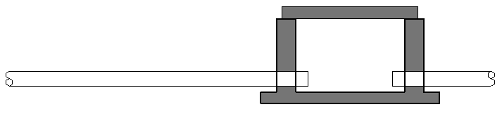

SECTION

FIGURE SCENARIO

Scenario 01-Non-compliant
Requirement | Minimum main drain-line pipe diameter should be 150mm.
Conditions | Should be connected to inspection chamber/s.
Description | Main drain-line pipe diameter = 125mm connected to inspection chamber.
MAIN DRAIN-LINE PIPE DIAMETER = 125MM
INSPECTION CHAMBER
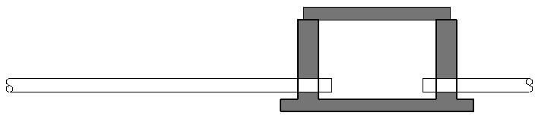

SECTION
FIGURE SCENARIO

Model PreCheck

Required Elements | Required Attributes
PipeSegment | IfcDescription contains “Main Drain Line”

Rule Parameters

System Type
Cold Water
Hot Water
 | Sanitary | 
 | Sewerage
Vent

Element Type 1
State | Type | Property | Operator | Value
Include | PipeSegment | IfcDescription | Contains | Main Drain Line
Exclude |  | Any | Match | N.A.
 |  | Name | N.A. | <User defined>

Element Type 1 Condition
Minimum diameter = | 150 | mm
* Should be connected to Inspection Chamber/s

Result Messages
- 3.1.3.2 (a) Main Drain-line
- Non-compliant (TotalResultNumeric)
- BuildingStorey (TotalResultPerFloorNumeric)
  - ElementName: Pipe diameter = ResultValueNumeric mm
- Compliant (TotalResultNumeric)
- BuildingStorey (TotalResultPerFloorNumeric)
  - ElementName: Pipe diameter = ResultValueNumeric mm
- Attention (TotalResultNumeric)
    - BuildingStorey (TotalResultPerFloorNumeric)
      - No inspection chamber to check.
      - No main drain-line to check.
      - Main Drain-Line is not connected to Inspection Chamber/s.

Sample Result Messages
- 3.1.3.2 (a) Main Drain-line
- Non-compliant (1)
- Level 1 (1)
- Main Drain Line Pipe 1.01: Pipe diameter = 125 mm
- Compliant (1)
- Level 1 (1)
  - Main Drain Line Pipe 1.02: Pipe diameter = 150 mm
- Attention (2)
    - Level 1 (1)
      - No inspection chamber to check.
    - Level 1 (1)
      - No main drain-line to check.
    - Level 1 (1)
      - Main Drain-Line is not connected to Inspection Chamber/s.

Sample Result Model Views
- 3.1.3.2 (a) Main Drain-line
- Non-compliant
- Plan view.
- Highlight checked element/space.
- All other elements are in translucent except checked element/space.
- Compliant
- Plan View.
- Highlight checked element/space.
- All other elements are in translucent except checked element/space.

Testing Scenario Notes
- Scenario 01-Compliant
- Level 1
- Main drain-line pipe of a residential house with a diameter of 150mm is located at its left side and
embedded in earth material with series of inspection chamber.

- Scenario 01-Non-compliant
- Level 1
- Main drain-line pipe of a residential house with a diameter of 125mm is located at its left side and
embedded in earth material with series of inspection chamber.

Model:
SSW 3132a-150-01-C_v4.ifc
SSW 3132a-150-01-NC_v4.ifc

Modelling Guideline
- Specify IfcDescription containing “Main Drain Line” for relevant PipeSegmentType.
- Specify Name containing “Inspection Chamber” for relevant DistributionChamberElementType.

Specification Log
RA | Alvin Q. Estocapio
Last edit date | 26 July 2018
ePC version
Updates | - V1

Specification Log
RA | Alvin Q. Estocapio
Last edit date | 13 August 2018
ePC version
Updates | - V2-Update rule interpretation and scenarios.

Specification Log
RA | Alvin Q. Estocapio
Last edit date | 22 August 2018
ePC version
Updates | - V3- Update rule interpretation, Model Pre-check, Rule Parameters, Result Messages and Modelling Guidelines

Specification Log
RA | Alvin Q. Estocapio
Last edit date | 12 September 2018
ePC version
Updates | - V4- Update rule interpretation, Model Pre-check, Rule Parameters, Result Messages and Modelling Guidelines

